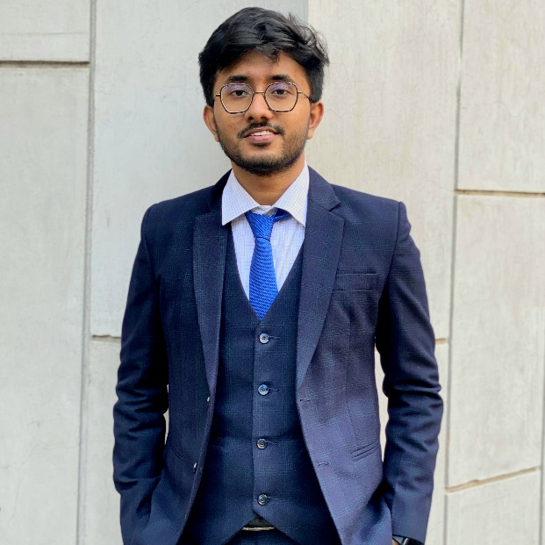

Linkedin:  
www.linkedin.com/in/tausif-al-rabby-a86195338

Github:

https://github.com/Tausif24apk

**GRAPHIC DESIGNER** (May 2022 – February 2024 )

* A graphic designer of Pathashishu Foundation.

**REGIONAL COORDINATOR** (May 2022 – February 2024 )

* Leading a team of Pathashishu Foundation with 42 members from Dhaka region

**GRAPHIC DESIGNER** (December 2024 – till now )

* A general member at graphic designer team at Southeast university.

**SCIENCE TUTOR** (May 2020 – till now)

* Concentrated primarily on the subjects Physics Chemistry Math and intermediate ICT .

**EXPERIENCE**

**On going B.Sc Degree**

Major in COMPUTER SCIENCE & ENGINEERING

From SOUTHEAST UNIVERSITY

**H.S.C (GPA-5.00)**

2021 (SCIENCE)

From DHAKA CITY COLLEGE, Dhaka

**S.S.C (GPA-5.00)**

2019 (SCIENCE)

From SIRAJ UDDIN SARKAR VIDYANIKETAN AND COLLEGE

**EDUCATIONS**

**Shahriar Manzoor**

Chairman & Associate Professor CSE Department,

Southeast University, Dhaka

smanzoor@seu.edu.bd

* CODING
* PUBLIC SPEAKING
* FOOTBALL
* WILD ANIMAL CARE

**REFERENCE**

**HOBBIES**

**LINKS**

* C, C++, Python
* Adobe Illustrator and Photoshop
* MS Word, Powerpoint, Excel
* Collaborative Leadership
* Tutoring class 8-12 students

**SKILLS**

I am an experienced programmer with expertise in C and C++, along with strong skills in Adobe Photoshop and Illustrator. Passionate about technology and design, I am always looking for new opportunities to enhance my coding skills and experience into a role in Data analysis.

**ABOUT ME**

CELL: +8801766313607

EMAIL: tausifalrabby24@gmail.com

ADDRESS: House # 219/6, Sarkar Tower(5-B), Sultanganj Road,

Dhanmondi, Dhaka 1209

TAUSIF AL RABBY

* Regional Coordinator
* A graphic designer
* Math Olympiad
* Science project leader

**CERTIFICATIONS**